Design Documentation

Measuring process of LEM sensors

|  |  |  |
| --- | --- | --- |
| **Approved** | | |
|  | Name | Signature |
| ennos gmbh |  |  |
| amrosolar |  |  |

|  |  |  |
| --- | --- | --- |
| **Distribution** | | |
| Company/Department | Name | Signature |
|  |  |  |
|  |  |  |
|  |  |  |
|  |  |  |

Table of content

Measuring process of LEM sensors 1

1 History of Changes 3

2 Introduction 4

2.1 Purpose of this Document 4

2.2 Coverage of this Document 4

2.3 Terms, Definitions und Abbreviation 4

2.4 Related Documents 4

3 Global project description 6

3.1 Introduction 6

3.2 System Overview 6

# History of Changes

The changes were inscribed from the first approved version (1.0.0). Before a change is inscribed, the version number of the document has to be inscribed.

|  |  |  |  |  |
| --- | --- | --- | --- | --- |
| Number | Page / Chapter | Description | Date | Name |
| 1 |  | Version 1.0.0 prepared |  |  |
| 2 |  |  |  |  |
| 3 |  |  |  |  |
| 4 |  |  |  |  |
| 5 |  |  |  |  |
| 6 |  |  |  |  |
| 7 |  |  |  |  |
| 8 |  |  |  |  |
| 9 |  |  |  |  |
| 10 |  |  |  |  |
| 11 |  |  |  |  |
| 12 |  |  |  |  |
| 13 |  |  |  |  |
| 14 |  |  |  |  |
| 15 |  |  |  |  |
| 16 |  |  |  |  |
| 17 |  |  |  |  |
| 18 |  |  |  |  |
| 19 |  |  |  |  |
| 20 |  |  |  |  |
| 21 |  |  |  |  |
| 22 |  |  |  |  |
| 23 |  |  |  |  |
| 24 |  |  |  |  |
| 25 |  |  |  |  |
| 26 |  |  |  |  |
| 27 |  |  |  |  |
| 28 |  |  |  |  |
| 29 |  |  |  |  |
| 30 |  |  |  |  |

# Introduction

This document is a manual to show how to perform measurements for current sensors. It addresses oneself to bfh technicians who will perform future measurements.

## Terms, Definitions und Abbreviation

|  |  |
| --- | --- |
| Abbr. | Description |
|  |  |
|  |  |
|  |  |
|  |  |
|  |  |
|  |  |
|  |  |
|  |  |
|  |  |
|  |  |

## Related Documents

|  |  |  |  |
| --- | --- | --- | --- |
| Ref. Nr. | Document | Description | Author |
|  |  |  |  |
|  |  |  |  |
|  |  |  |  |
|  |  |  |  |
|  |  |  |  |
|  |  |  |  |
|  |  |  |  |
|  |  |  |  |
|  |  |  |  |
|  |  |  |  |

# Global project description

## Introduction

LEM wants to test several of their current sensors in order to determine their behaviour under realistic conditions as they happen in an electric vehicle. This means that not only a constant current is applied to the sensors, but a complete current-over-time profile. One main purpose of the current sensors is the calculation of the SoC of the battery. For this, there is a small tolerance of offset current, because already small errors will accumulate to big charge differences, biasing SoC calculation. Because of this, the main output of these measurements is the Charge difference between the device under test and a reference sensor.

## System Overview

The following parts are taken from the document “2014-02-21 Technical Proposal_1.4.docx”, which described the measuring process in the first place.

R

PCMCIA

Agilent 34972A multimeter

Ethernet

CAN output

PWM output

Ethernet

Evaluator-B

Test bench

0..5V

0..600A

Temperature chamber

NI Series 2

LeCroy oscilloscope

Analogue voltage output

Laptop

with LabVIEW

HMI

DC

Analogue

current

output

USB

LIN output

NI USB-9866

Figure 1 System Overview

Basically, the system consists of one reference sensor and one or more devices under test, the Fuelcon test bench to generate the current profile and a laptop together with measurement equipment to get the results.

In order to use the Fuelcon test bench, a dummy battery has to be installed to generate the necessary minimum voltage higher than 1V. For this, a specially assembled battery block has been made, which can be reused.

If the sensor has to be tested under different temperatures, a thermal chamber can be used. In this case, the device under test is put into the temperature chamber, while the reference sensor is kept outside it. This assures that the temperature drift of the reference sensor is kept minimal.

# Setup procedure

## Introduction

This chapter proposes the necessary steps in the case that a new sensor provided by LEM will be tested. It tries to list the issues and pitfalls that occurred during the test of the first sensor (the CAB 300-C)

## Mechanical installations

### Cabling

The high current circuit is built up with several high diameter power cables. Figure 1 shows schematically the flow of the high current. Figure 2 and Figure 3 show the currently implemented installation:

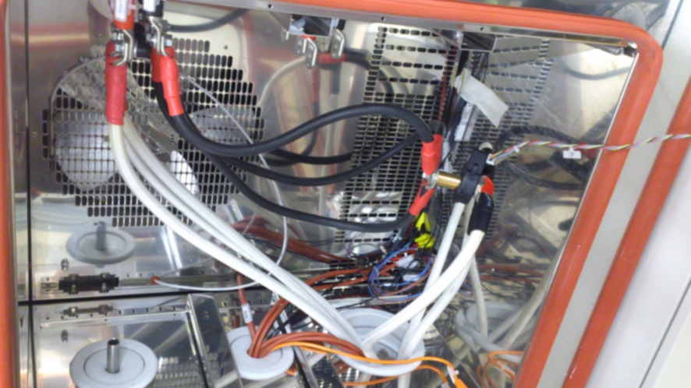

Figure 2: cabling inside temperature chamber

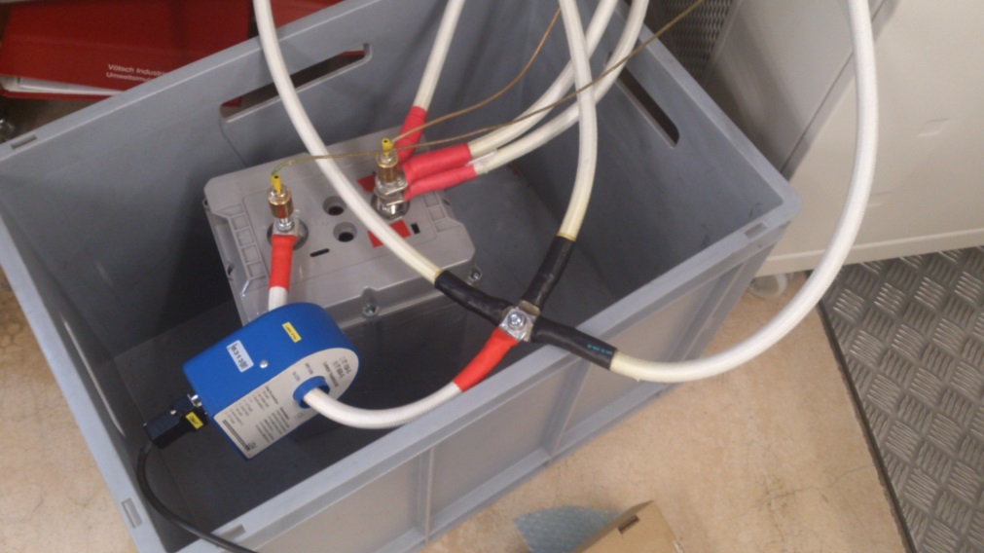

Figure 3: cabling in box outside temperature chamber

In the following, the segments of this circuits are analysed in detail:

* The three cables from the three channels are routed in parallel: 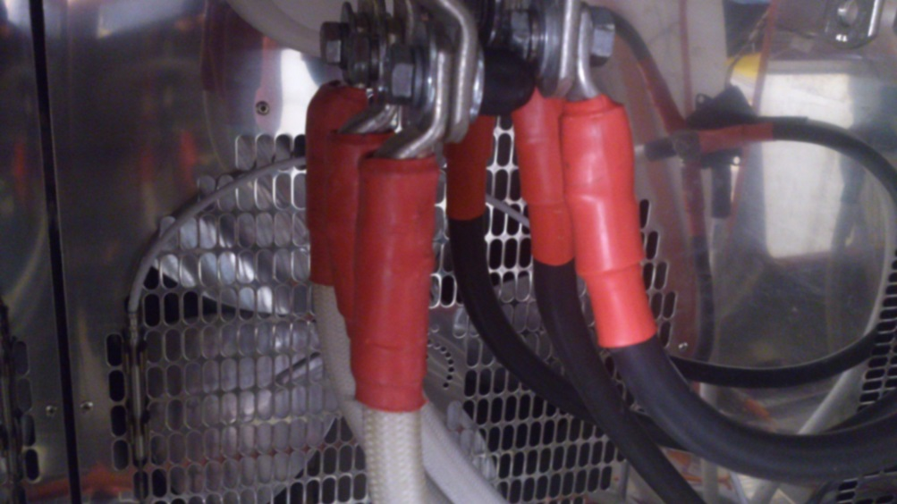

Figure 4: connection of three power cables in temperature chamber

* At the dummy battery, the cables are connected like this:   
  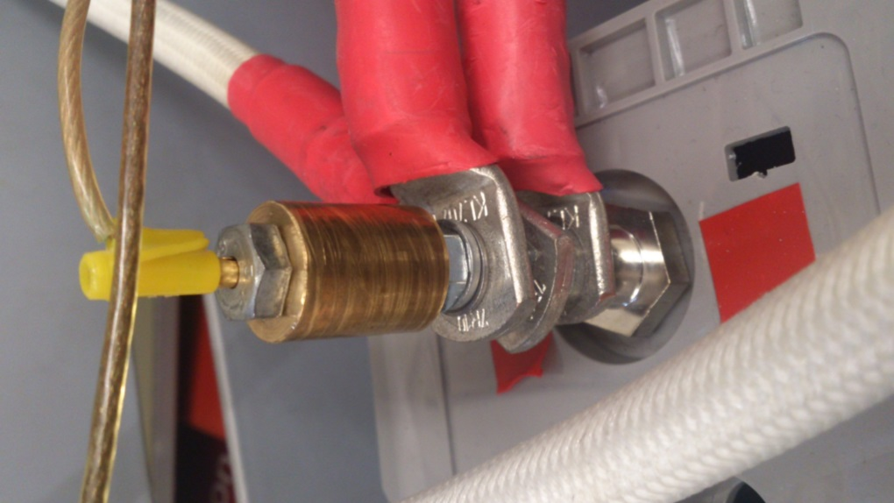  
  Between the power cable connectors, there is always one nut. This ensures an easier assembly. The bronze cylinder on the top is just to install the plugs for the cell voltage measurement for Fuelcon. It has an inner screw thread, so it can be screwed on the threaded rot on which the current plugs are mounted.
* In order to measure the cell voltage of the dummy battery with the Fuelcon test bench, there was made a simple installation which splits the cabling from the two poles to three channels each. This is because each of the three channels of the Fuelcon test bench has to measure a valid voltage in order to avoid alarm state.

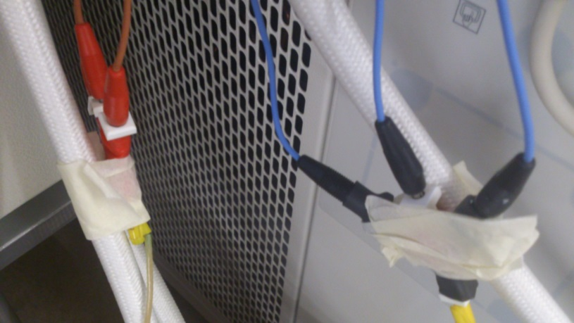

Figure 5: splitting of the battery potentials

* From the negative pole of the battery, one thick cable leads through the reference sensor: 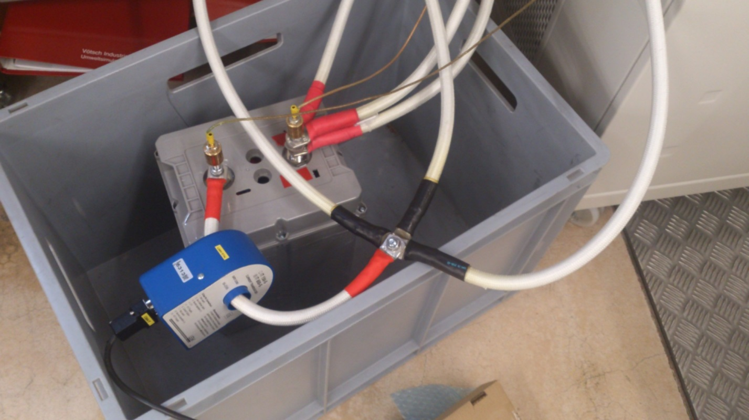

Figure 6: connection of reference sensor

The connection of the cable is similar as shown in the last point, just only with one cable.

* Then, the cable is split again in three separate cables:  
  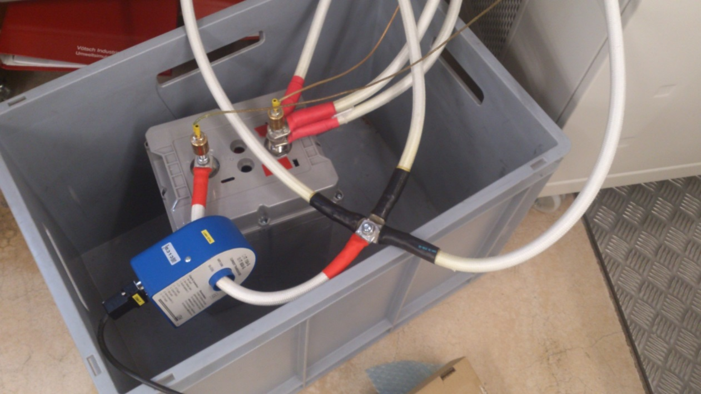

Figure 7: splitting after reference sensor

* Again, three cables are fed back into the temperature chamber, where they are connected to a cylindrical rod, which is shown in Figure 6. The assembly can be done with two M8 screws, two spring washers and two normal washers.
* From the other side of the rod, again three cables are fed to the negative pole of the fuelcon test bench. The circuit is closed.

### Install new sensor under test

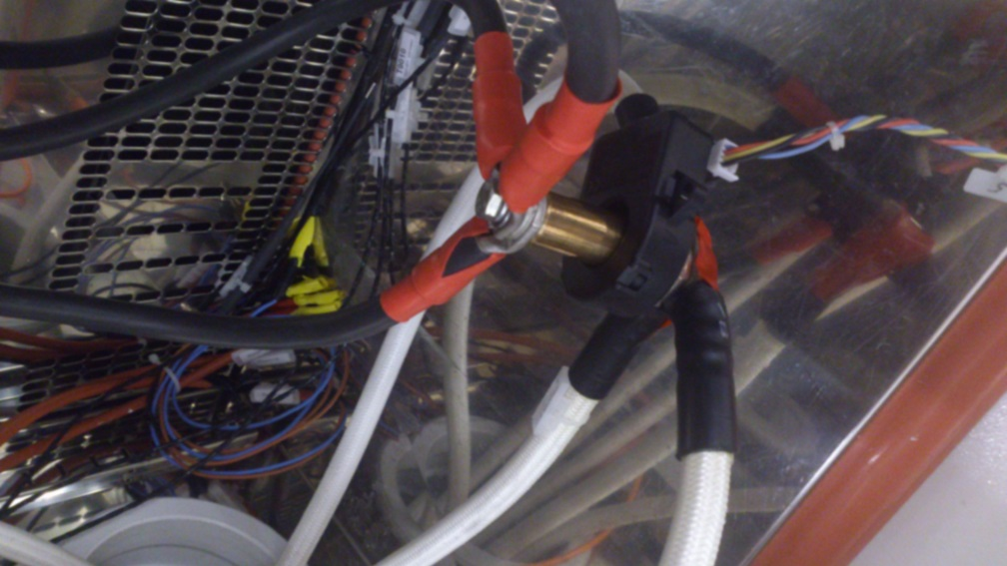

Figure 8: installation of the sensor under test

In order to deliver enough current to the sensor, a special cylindrical part was assembled, with which all three channels can be connected in parallel. This is shown in Figure 2 (bronze part). With this, up to 600A are possible. The connections can be easily removed to exchange the sensor.

If the new sensor should have a diameter smaller than 20mm or a width larger than 48mm, then another part has to be assembled.

### Install reference sensor

### Install dummy battery

### Measurement for Fuelcon test stand

## Software steps

### Generate xml file from csv file

### New LabVIEW code for sensor under test

### Testworks adaptations

## Documentation

### Standards used in the first measurement